SMART WASTE MANAGEMENT

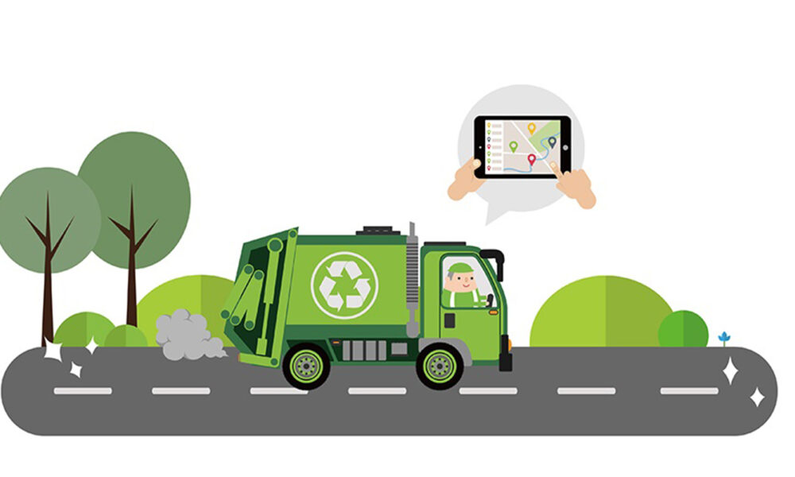

PROJECT PLANING II

|  |  |
| --- | --- |
| **DATE** | **24.10.2022** |
| TEAM ID | **PNT2022TMID34358** |
| **PROJECT NAME** | **SMART WASTE MANAGEMENT FOR METROPOLITAN CITIES** |
| **MAXIMUM NUMBER** | **4 MARKS** |

**TEAM LEADER**

* MEENAKSHI.R

**TEAM MEMBER:**

* Kavitha.s
* MARY JAVKEY RUHISHA.S
* LIBISHA.K.J

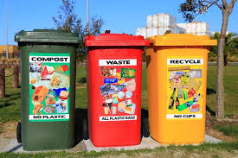DATA FLOW DIAGRAM AND USER STORIES

***Think outside the trash..******Recycle!******Don't throw money in the trash – recycle all – it's your decision..!!!***

**Data Flow Diagrams:**

. A data flow diagram (DFD) maps out the flow of information for any process or system. It uses defined symbols like rectangles, circles and arrows, plus short text labels, to show data inputs, outputs, storage points and the routes between each destination. Data flowcharts can range from simple, even hand-drawn process overviews, to in-depth, multi-level DFDs that dig progressively deeper into how the data is handled. They can be used to analyze an existing system or model a new one. Like all the best diagrams and charts, a DFD can often visually “say” things that would be hard to explain in words, and they work for both technical and nontechnical audiences, from developer to CEO. That’s why DFDs remain so popular after all these years. While they work well for data flow software and systems, they are less applicable nowadays to visualizing interactive, real-time or database-oriented software or systems.

A data flow diagram (DFD) **maps out the flow of information for any process or system**. It uses defined symbols like rectangles, circles and arrows, plus short text labels, to show data inputs, outputs, storage points and the routes between each destination.

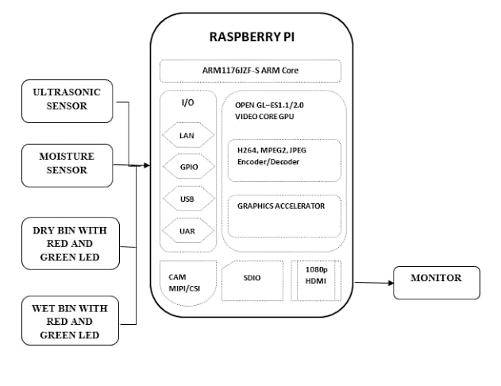**User Stories**

Use the below template to list all the user stories for the product.

|  |  |  |  |  |  |  |  |  |  |  |  |  |  |  |
| --- | --- | --- | --- | --- | --- | --- | --- | --- | --- | --- | --- | --- | --- | --- |
| **User Type** | **Functional**  **Requirement (Epic)** | **User Story**  **Number** | **User Story / Task** | **Acceptance criteria** | **Priority** | **Sprint** | **Release** |  |  |  |  |  |  |  |
| Customer  (Mobile user) | Registration | USN-1 | As a user, I can download the application | I can view the data sent by hardware | High | Sprint-3 | Sprint-3 |  |  |  |  |  |  |  |
| Customer (web user) | Registration | USN-1 | As a user, I can view the application web page | I can view the data sent by hardware | High | Sprint-3 | Sprint-3 |  |  |  |  |  |  |  |
| Customer (Data types) | Data viewing | USN-1 | As a user, I can view garbage level monitoring | Data by the hardware | High | sprint -1 | Sprint-1 |  |  |  |  |  |  |  |
|  |  | USN-2 | As a user, I can view the level of wastage | Data by the hardware | High | Sprint-1 | Sprint-1 |  |  |  |  |  |  |  |
|  |  | USN-3 | As a user, I can view the level of dustbin is detected | Data by the hardware | High | Sprint-1 | Sprint-1 |  |  |  |  |  |  |  |
| Customer | Actions | USN-1 | As a user I can receive notification appears in the phone | I receive notification | Medium | Sprint-2 | Sprint-2 |  |  |  |  |  |  |  |
|  |  | USN-1 | As a user I need sensor Access which connected to mobile | Based on the sensor the level of the garbage will monitored | Medium | Sprint-2 | Sprint-2 |  |  |  |  |  |  |  |
| Administrator | Storage | USN-1 | As an administrator I can store the data | All the data are stored in cloud database | High | Sprint-4 | Sprint-4 |  |  |  |  |  |  |  |

...< >…